Lesson 1 Creating a Virtual Private Cloud

Alen Ovalles

Purpose

The purpose of this lesson is to familiarize ourselves with the AWS management console and the basics of creating an Amazon Virtual Private Cloud (Amazon VPC) with working public and private subnets connected to an internet gateway.

Process (w/ pictures)

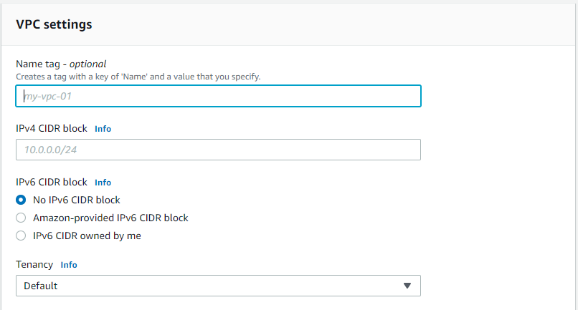

1) Create a non-default Amazon VPC

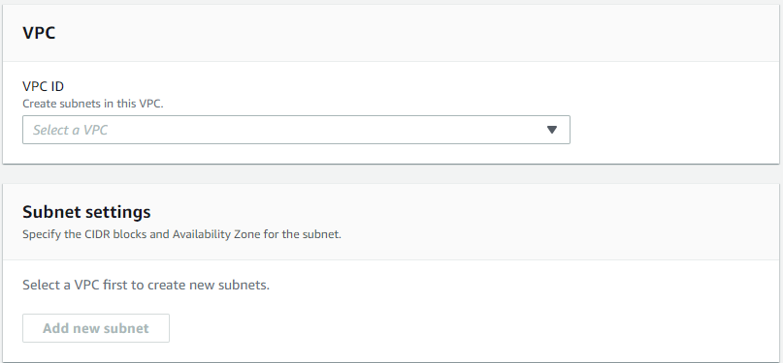

2) Create a public/private subnet

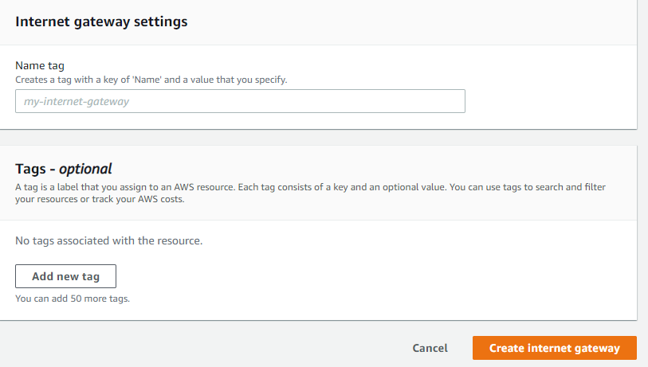

3) Create an internet gateway

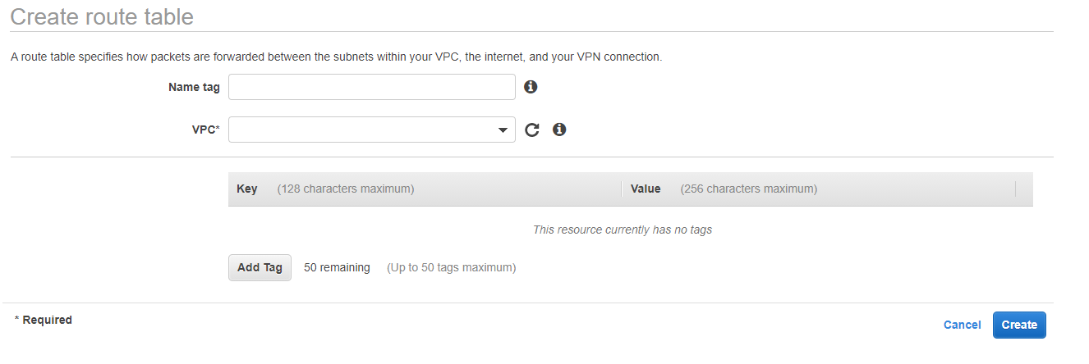

4) Create route table, add routes, and associate route table

Problems

There was really any problem with this first lab or was there a difficulty finishing it. Was straightforward in the lesson 1 PowerPoint guide in how to do the steps and what they are for. I was just to set up the console for other lessons.